**STAKEHOLDERS OPEN COLLABORATION SPACE (SOCS) User Manual**

Contents

[1 Acronyms 2](#_Toc101342231)

[2 List of Authors 2](#_Toc101342232)

[3 Introduction 2](#_Toc101342233)

[4 Platform Overview 2](#_Toc101342234)

[5 How to join the platform 3](#_Toc101342235)

[6 Platform roles 4](#_Toc101342236)

[7 How to use the DEMETER Workspaces 5](#_Toc101342237)

[7.1 Dock bar 7](#_Toc101342238)

[7.1.1 Search 7](#_Toc101342239)

[7.1.2 Personal profile 8](#_Toc101342240)

[7.1.3 Notifications 9](#_Toc101342241)

[7.2 SOCS Home page 10](#_Toc101342242)

[7.2.1 Collaboration tools 10](#_Toc101342243)

[7.2.2 Knowledge Management 16](#_Toc101342244)

[7.2.3 Catalogues 21](#_Toc101342245)

[7.2.4 Innovation Space 21](#_Toc101342246)

# Acronyms

|  |  |
| --- | --- |
| ACS | Access Control Server |
| CMS | Catalogues Management System |
| DYMER | DYnamic Information ModElling & Rendering |
| IDM | Identity Management |
| SOCS | STAKEHOLDERS OPEN COLLABORATION SPACE |
|  |  |
|  |  |
|  |  |
|  |  |
|  |  |

# List of Authors

|  |  |
| --- | --- |
| Company | Author |
| ENG | Francesca Cantore, Antonio Caruso |
|  |  |
|  |  |
|  |  |
|  |  |

# Introduction

This guide is intended to introduce you to the basics of the SOCS platform.

The document includes the following sections:

* A platform overview aiming at describe the rationale behind the product and the approach followed
* A section describing the steps needed to join the platform
* A Platform Roles description
* A chapter dedicated to the exploration of the main platform functionalities

# Platform Overview

The SOCS is a space dedicated to all stakeholders (farmers, advisors, and suppliers) where they can collaborate, share knowledge and best practices, and participate in the co-creation processes.

The SOCS provides the access point to the DEMETER ecosystem. The added value provided by the SOCS is mainly related to the capability to interconnect all the DEMETER stakeholders into a unified digital community, where to find new contacts, share best practices and get inspiration, facilitate the emergence of new collaborations, find update on relevant topics, learn from the others’ experiences, innovate, promote yourselves and create the basis for new business, have access to skills and technologies as well farmer’s requests and needs and expert advices.

During the design and development of the DEMETER workspace structure we have considered a high level user journey within the SOCS platform in order to orchestrate the ideal user experience and optimize it for the desired outcomes.

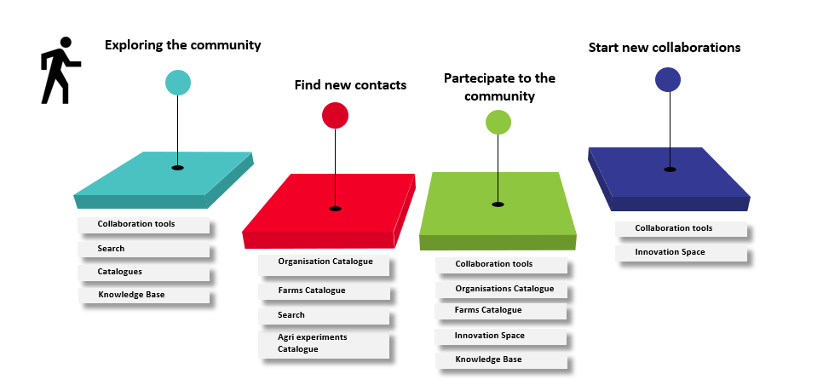

Figure 1 High level user journey

The SOCS is based on the DIHIWARE, a solution developed by the MIDIH H2020 EU project (<http://midih.eu>) and currently in use in many ecosystems in Europe. The DIHIWARE offers a complete collaboration environment inspired by Enterprise Social Software.

The DIHIWARE Innovation and Collaboration Platform is an integrated environment made of the following main systems: Collaboration Portal (CP) and Catalogues Management System (CMS).

The Collaboration Portal (CP) is the main subsystem, offering tools for knowledge management, social activity next to collaboration and innovation capabilities. It links users, processes, resources, and acts as a powerful knowledge hub. The Collaboration Portal is grounded on **Liferay**[[1]](#footnote-1) that has been selected since it is a widely used Open-Source and state-of-the-art Content Management System. The Catalogue Management System relies on **DYMER** (DYnamic Information ModElling & Rendering) which is a WCM (Web Content Management) completely developed by ENGINEERING within the MIDIH Project.

# How to join the platform

The current version of the platform is available at [https://socs.h2020-demeter-cloud.eu/](https://socs.h2020-demeter-cloud.eu/" \t "_blank" \o "https://socs.h2020-demeter-cloud.eu/).

All participants to their first joining to the platform can use all the services and applications available in the DEMETER SOCS workspace (the workspace common to all stakeholders) as Publisher users.

Access to the platform is controlled by clicking on Sign in (Figure 2) and using your ACS credentials (Figure 3).

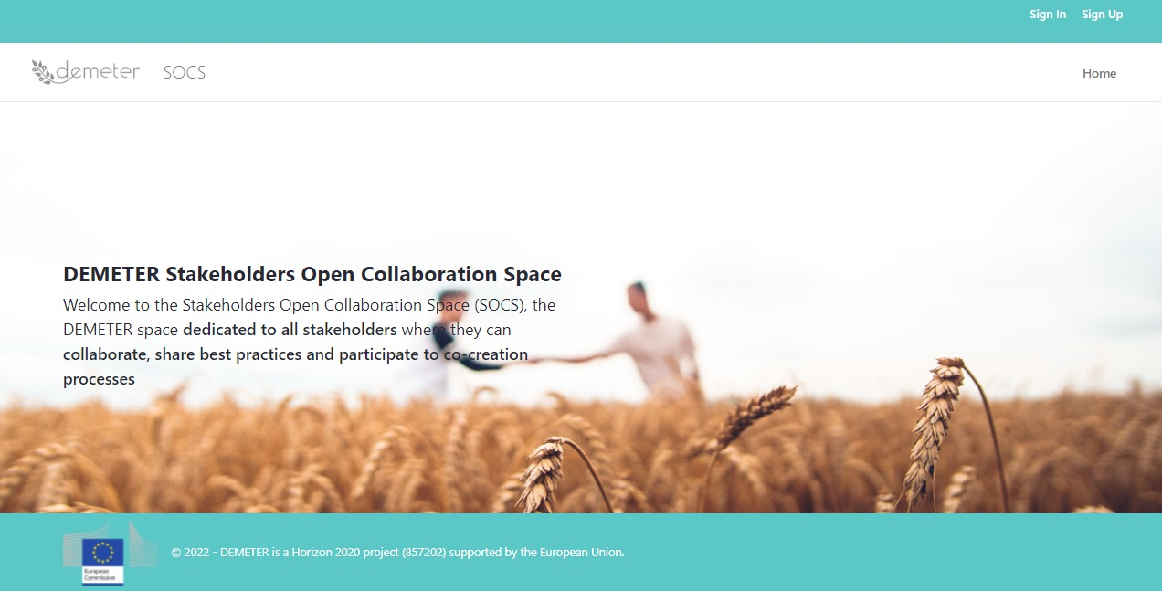

Figure 2 SOCS Public page

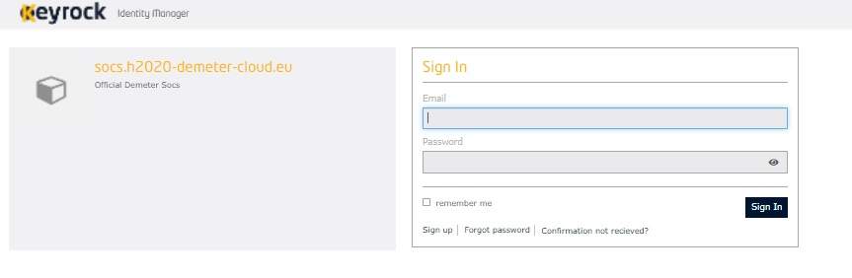

Figure 3 IDM login page

# Platform roles

Roles are used to collect permissions that define a particular function within the portal, according to a particular scope.

What follows is an overview of the available roles:

* **System Administrator**: The system administrator is the person who is responsible for the upkeep, configuration, and reliable operation of the SOCS Platform, seeking to ensure that the uptime, performance, resources, and security of the system. System administrator responsibilities are, fundamentally, about the care of the general system and also cover the specific applications. He is responsible for effective provisioning, installation/configuration, operation, and maintenance of systems hardware and software and related infrastructure. The main responsibilities are related to: installing and configuring software, setting up users’ accounts and roles, defining vocabularies and categories, managing technology tools, monitoring system performance, ensuring security through access controls, providing technical support.
* **SOCS publisher**: This role represents every single user accessing the Platform and using its functionalities. He can access a collaboration workspace where he can collaborate with other users and exploits platform functionalities such as comment a Blog, add a new thread, reply to a discussion, view Farm, Organisation and Agri-trial catalogues, view Documents and Wiki, add events. Through the Platform, he can manage to stay informed, to seek experts and specialists, to find and get expert shared knowledge.
* **Content Manager**: The Content Manager is a professional who provides expert advice in a particular area, such as the different agricultural domains (this for example can coincide with cluster topics in the Discussion), technology (this for example can coincide with technical documentation) or any of many other specialised fields. They represent an expert or an experienced professional in a specific domain and has a wide knowledge of the subject matter, being able to use it for business purposes. They have no administrative role, but he acts as an honest broker, trying to help people and organisations to resolve a problem or arrange a deal by talking to all sides and finding out what they want, without favouring any one side but factorising competences and solutions. Besides being a mediator, considering their long business experience and domain knowledge, they will represent an animator of discussions, a blog publisher, a document library organiser.
* **Organisation/Farm/Pilot Content Manager**: This role allows to add detailed characteristics for each specific organisation, farm and pilots (or agri-trial). The users with this role will be responsible for the updating of all aspects of the organisation/farm/pilots. He will be in charge of writing, editing and proof reading these contents. Each pilot leader, thanks to this role, will be able to add information related to his/her pilot.
* **Challenge Author Manager**: The Challenge Author Manager, could be a farmer or a farmer association representative, able to create, through the co-creation application, a challenge which consists in a farmer need.

# How to use the DEMETER Workspaces

The workspace is managed by the system administrator and offers a collaborative working environment, equipped with useful tools and functionalities, in order to support collaboration and collective knowledge management.

In the SOCS, two different workspaces (which are spaces with the needed collaborative applications to satisfy specific users’ interests) have been configurated. Indeed, the current structure is based on a workspace for all the DEMETER participants (**SOCS workspace**) and a workspace just for developers (**DEVELOPERS workspace**). The former offers common repositories to discover organisations and farms’ core activities as well as pilots’ catalogue and will aim at facilitating the creation and sharing of agricultural and digital contents, information, news, events, best practices, knowledge, challenges among all the different categories of users. The latter aims at representing a virtual space to enable the collaboration among developers, mainly through the sharing of technical documentation that will be made available by using the wiki application (tool to formalise users’ knowledge in a structured way), the document library and through categorized discussions to solve specific issues.

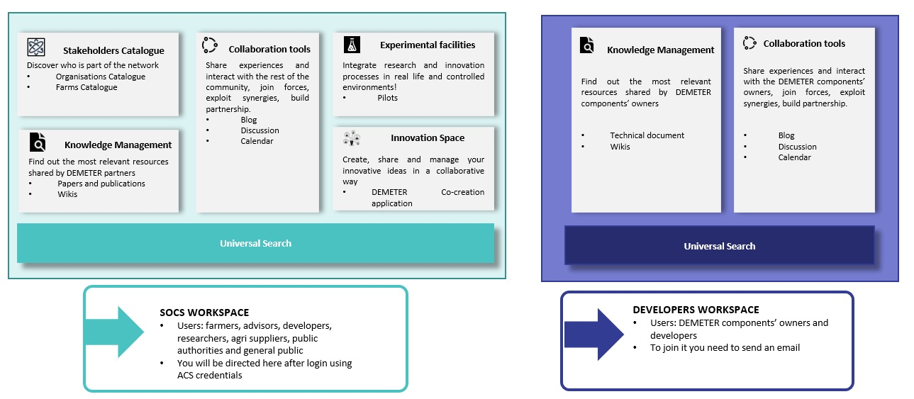

Figure 4 Workspaces: SOCS and Developers

After login using ACS credentials, the user will be directed in the SOCS workspace as Publisher. In case he/she, as DEMETER component owner or as pilot developer, wants to join the DEVELOPER space, he/she has to send an email to [SOCS\_operator@h2020-demeter.eu](mailto:SOCS_operator@h2020-demeter.eu).

Once in the SOCS workspace, the user can see the Home page where a list of all the recent resources (Blog, discussion and wiki) are shown reporting the title, the type of the resource, the assigned categories and tags, an excerpt of the resource.

Figure 5 SOCS home page

If a user, member of both the workspaces, has to change workspace, he/she has to go on My Profile (at the top bar, on the right) and click on My sites, where he/she can select the interested site.

Figure 6 User profile

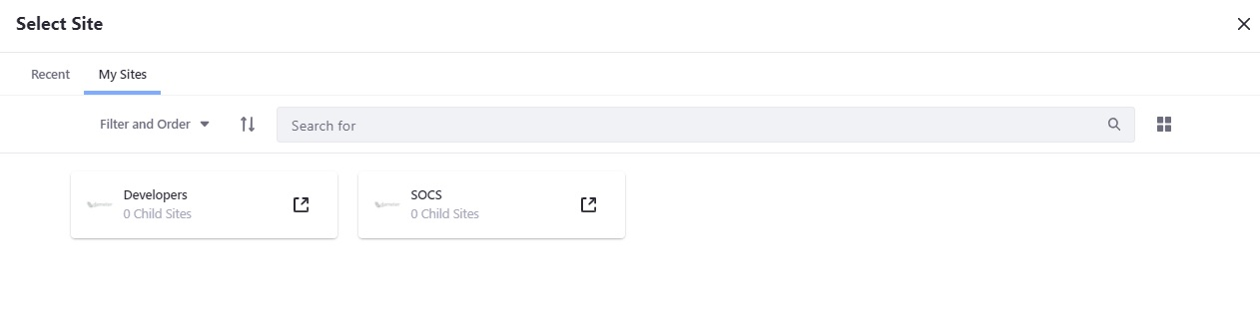

Figure 7 Select site

## Dock bar

The functionalities available in the Dock bar (the bar on the top) are:

* **Search**, where workspace participants can look for all the portal content;
* **Personal profile**, by clicking on the icon, workspace participants can access their profile, add their skills and sign out from the platform.
* **Notifications**, the notifications icon on the profile image shows the user his number of unread notifications or requests.

### Search

The platform includes a search feature to help users quickly find what they are looking for, or just to browse through content and people. With this service (always at the top of the user interface) it is possible to search for specific words, to find content by categories or tags or restrict the search to certain resources. For example, a user, who looks for partners with development skill, can write “development” in the search bar and then restricts his/her search, selecting “User” in the section Type on the left. The search result will be a list of users who have assigned themselves this specific skill in their profile.

Figure 8 Search

### Personal profile

By clicking on the personal profile icon and then on My profile, workspace participants can access their profile (Figure 8).

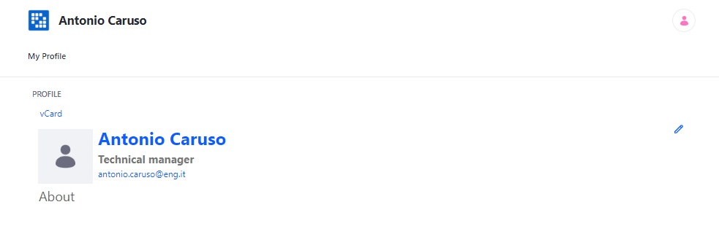

Figure 9 My Profile

Clicking on the edit icon on the right, the user can edit his/her personal information, add his/her skills (Figure 10), check his/her roles (Figure 11).

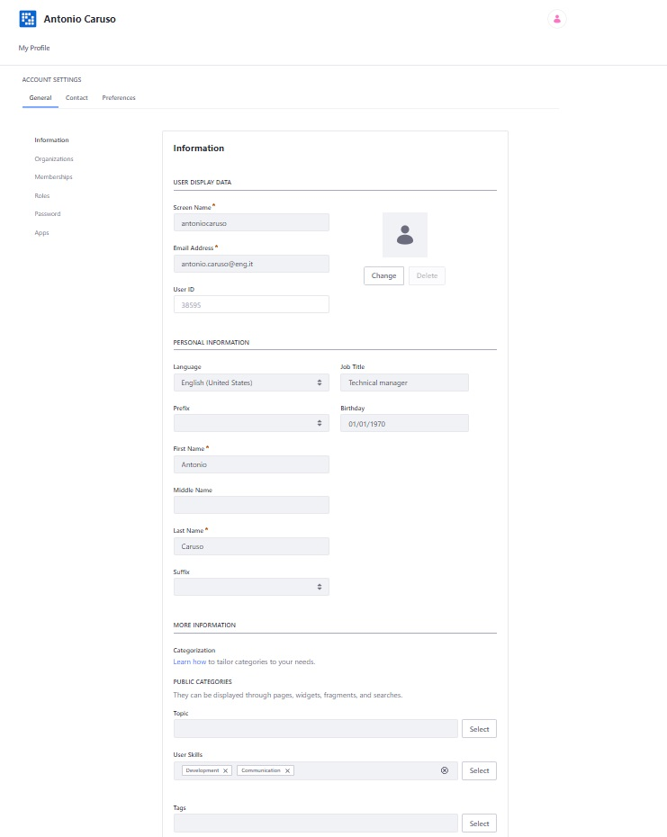

Figure 10 View/Edit My profile

Figure 11 View roles

To come back to the Private pages from “My profile”, the user has to click on the Profile icon, click on My sites and select the site.

### Notifications

Through the Notifications application, if the user is subscribed to a blog or a discussion and someone participates to that blog/discussion, he receives a notification. The notifications icon on his profile image shows his number of unread notifications.

To access notifications, the user can click the notifications icon on his user profile image or select  Notifications under the user menu.

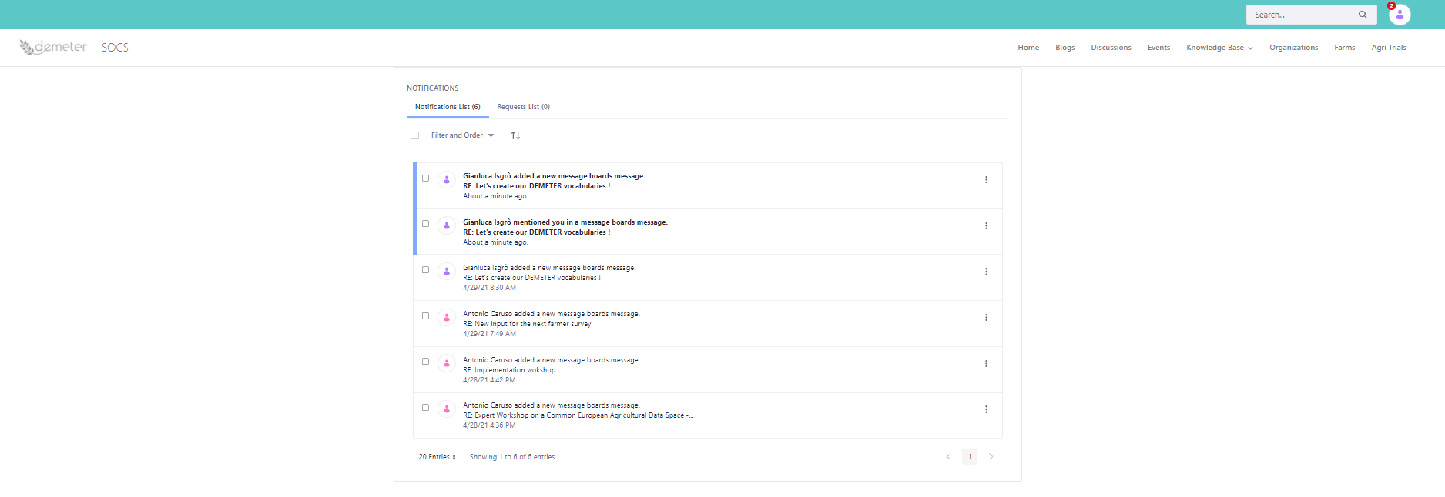

Figure 12 Notifications icon and unread notifications

## SOCS Home page

The SOCS Home Page includes, at the top, the main menu which gives the user the entry point to the platform services which are: Discussions, Blog, Knowledge Base services (Documents and Wikis), Calendar and Catalogues (Organisations, Farms, Pilots/Agri experiments).

In the main part of the home page, the user can find the recent blogs, discussions and wiki created.

In the right part of the home page, the user can find the recent bloggers.

Figure 13 SOCS Home page

### Collaboration tools

#### Discussions

The discussions application contains the threads open within the workspace.

In this application it is possible to identify 5 different sub-applications:

* Categories: from this section is possible to see the main containers (identified by the content managers) in which users can start new threads. User can also start threads which are not connected to any created categories.
* Recent posts: this section collects the posts published by all DEMETER users recently.
* My posts: this section collects all the posts published by the user.
* My Subscriptions: this section includes the categories and threads to which the user subscribed.
* Statistics: this section includes the total number of categories, the total number of posts and the total number of participants which have participated in all the discussions.

The discussion application also includes a search feature which allows to search for the threads which include a specific keyword.

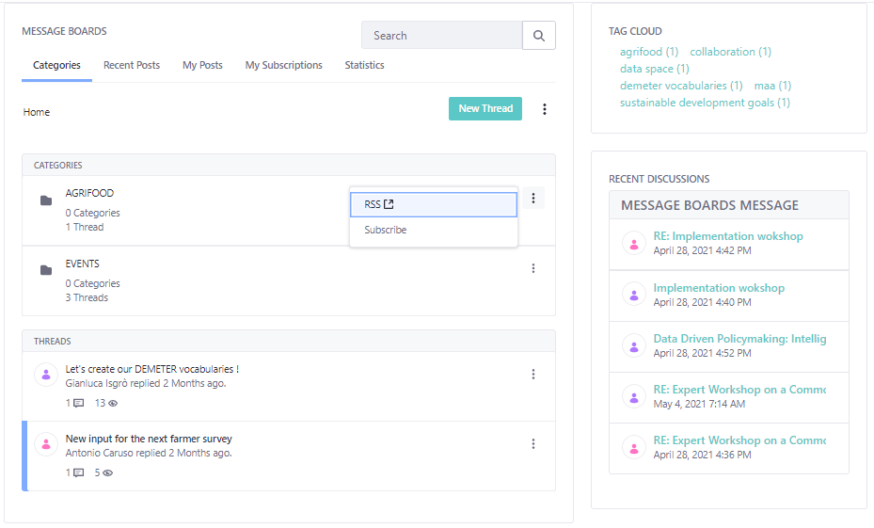

Figure 14 Discussion

The user is able to:

* Subscribe to all open threads
* Add a new thread

When the user adds a new thread, he can insert:

* A subject
* A description
* Attachments
* Tags or predefined categories
* Related assets

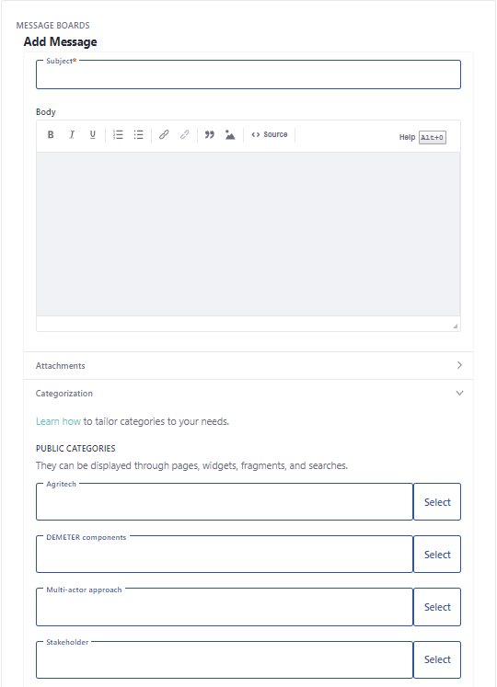

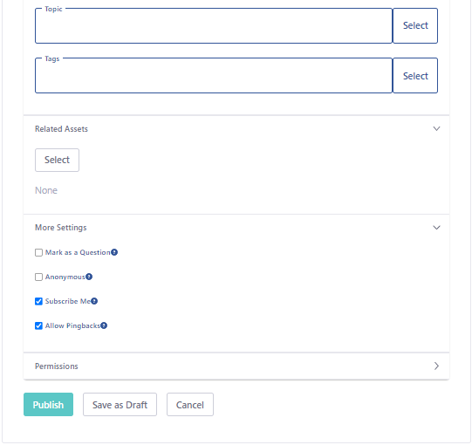

Figure 15 Add new thread

Users can reply to messages  , You can also use the to quote from messages that you are replying to.

#### Blog

The blog section contains all the articles that users would like to share with the team.

Figure 16 Blog

The actions bar allows users to subscribe to the Blog section, to add a new blog article through the botton “New entry”. When the user adds a new blog, he can insert:

* An image
* A title
* A subtitle
* A content
* Tags or predefined categories
* A related asset

Every blog article could be commented by the team users. If the user is the article owner he can also edit or delete it.

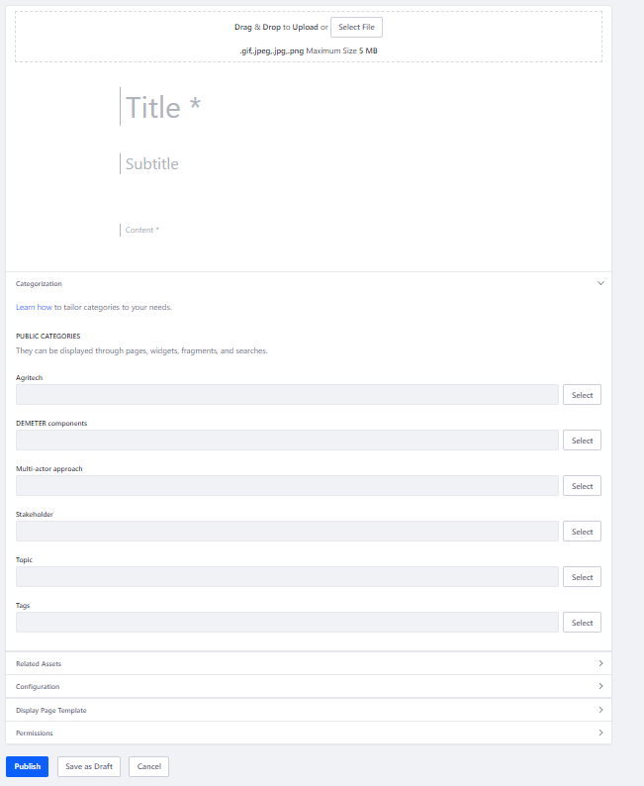

Figure 17 Add new Blog

#### Calendar

The Calendar application allows users to create, track, share and manage events.

It is possible to visualise all the workspaces’ calendars (those to which the user belongs) and the personal calendar.

Figure 18 Events

To add events to a calendar, the user can click on any day of the calendar and an event creation popup appear or can click on “Add event” where he can edit:

* A title
* A start and an end date
* A description
* Tags or predefined categories
* A related asset

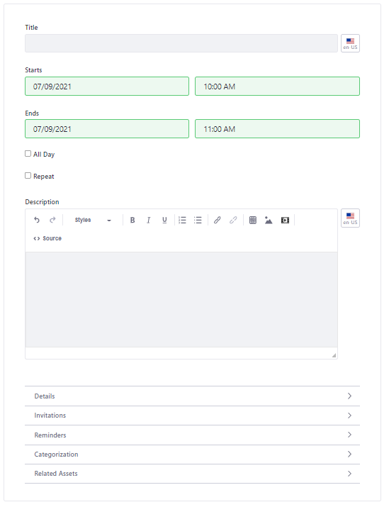

Figure 19 Add event

### Knowledge Management

#### Documents

Documents provides a mechanism for storing files online using the same type of structure that it is used to store files locally.

To add a new folder or upload a new file, the user has to click on Knowledge Base and then Documents (in the top bar). Here the user can click on “Documents and Media +” button (Figure 18).

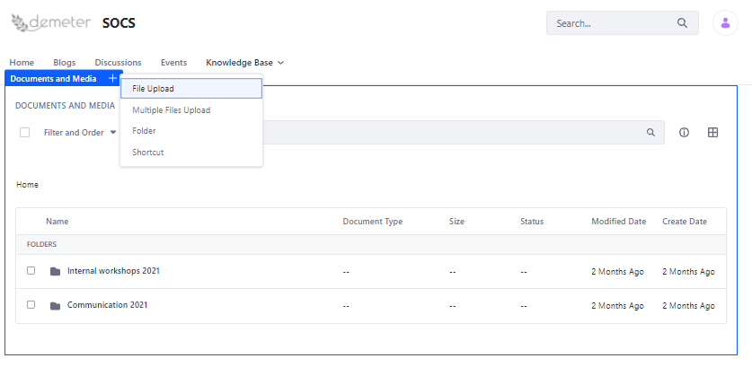

Figure 20 Documents

To create a new folder the user has to:

* Add a name
* Add a description

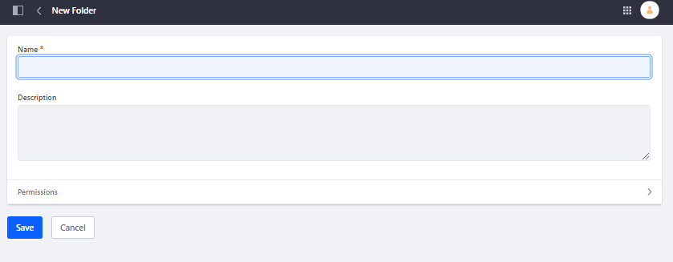

Figure 21 Create new folder

To add a new document the user has to:

* Select the file he wants to upload
* Add a name
* Add a description
* Add tags or predefined categories
* Add a related asset

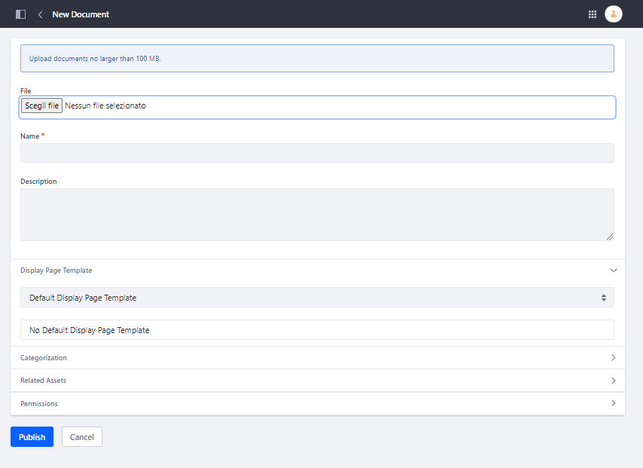

Figure 22 Add new document

To download a document, the user has to:

* Click in the name of the file
* Click on the button “Info”
* Click on the button “Download”

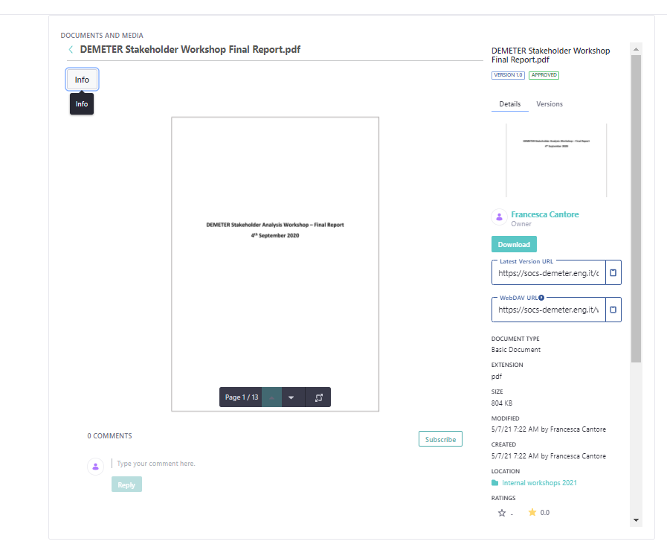

Figure 23 Download document

#### Wikis

To add a new folder or upload a new file, the user has to click on Knowledge Base and then click on Wiki.

The wiki is an application which allows users to collaboratively build a repository of information.

Figure 24 Wiki

The wiki toolbar allows user to subscribe, add wiki pages and navigate the wiki portlet.

At the top of the wiki, the user can see:

**Recent Changes**: which shows all of the recently updated pages.

**All Pages** which shows a flat, alphabetical list of all pages currently stored in the wiki. Through this page, clicking on the three dots, the user will have access to a series of actions (i.e. delete a wiki or move it or copy it, etc.)

**Orphan Pages**: which shows a list of pages that have no links to them.

**Draft Pages**: which shows a list of pages which have not yet been published. Users can edit pages and save their changes as drafts. They can come back later to finish their page changes and publish them once they have been approved.

When the user adds a page, he has to complete the following sections:

* Title (required)
* Content
* Categories and tags
* Related assets

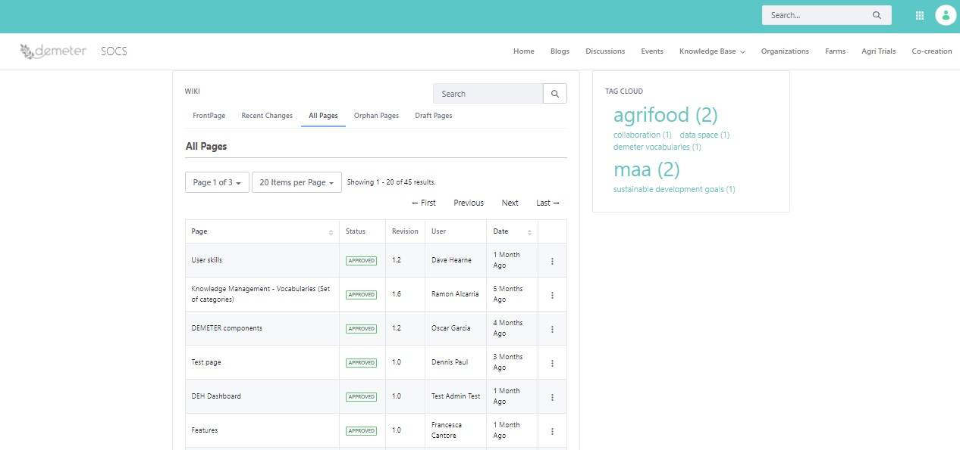

Figure 25 All pages

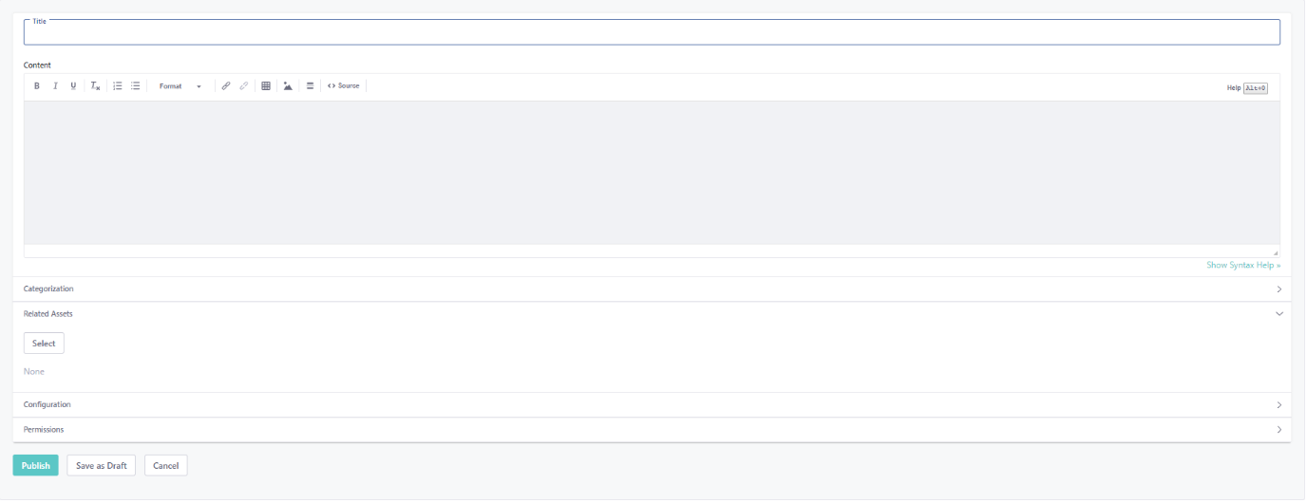

Figure 26 Wiki detail

### Catalogues

All users, who access to the SOCS workspace, have the possibility to view all the organisations, farms and agri-trials (or pilots) information collected in the catalogues. The user, who wants to become author (owner) of his own organisation (or farm or pilot) in order to create or modify it, has to send an email to [SOCS\_operator@h2020-demeter.eu](mailto:SOCS_operator@h2020-demeter.eu). The author, who creates his own organisation (or farm or pilot), can add a co-editor who will also be able to edit it.

#### Organisations

The application allows users to search for organizations, looking them up from the registered entities of the portal, and retrieving the full descriptions and details. The Search functionality allows to search for key words.

Once you have accessed to the Organisation application the user can see a list of organisations in a card view (Figure 27) or in a map&table view (Figure 28). To access to the detailed view of an organisation, the user can click on the organisation card (cards view) or on the eye icon in the list within the map&table view. The different views can be setup just from the admin.

If the user has the role of Organisation Content Manager, then he will see at the top of the Organisation application interface, the button “+ Organisation”.

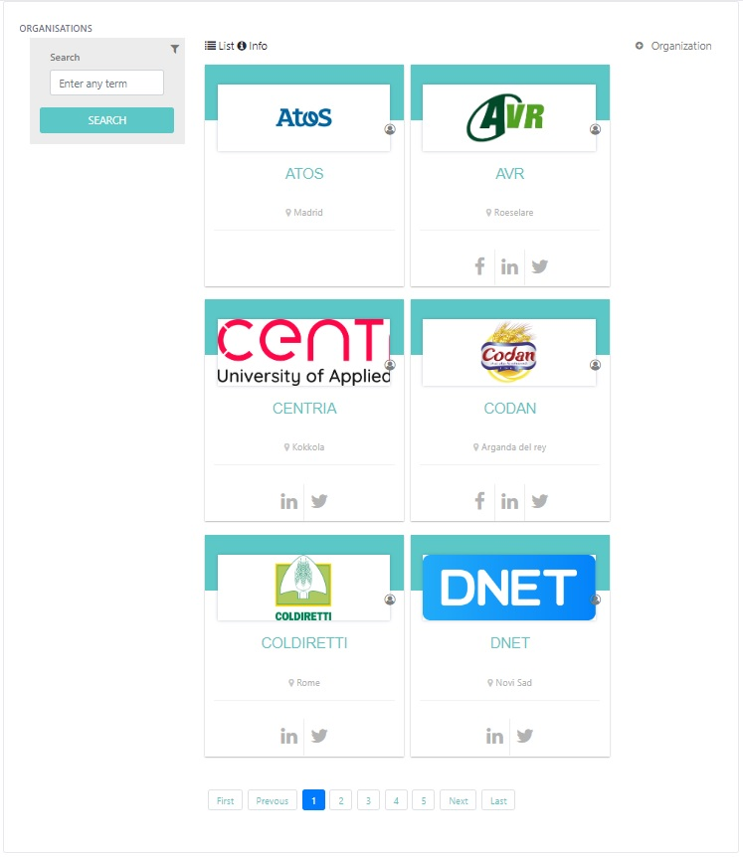

Figure 27 Organisation cards view

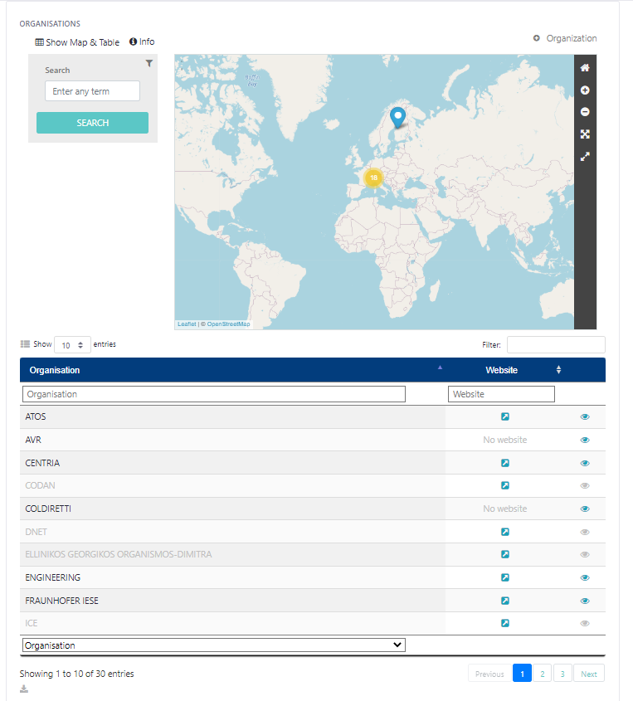

Figure 28 Organisations map&table view

Clicking on the yellow point in the Map&Table view, the user has the possibility to see all the locations of the different organisations added in the catalogue (Figure 29).

Figure 29 Locations markers map

Clicking on a specific location marker, the user can view some short information about the organisation (Figure 30). Through the “View more” the user can access to all the organisation’s details (Figure 31).

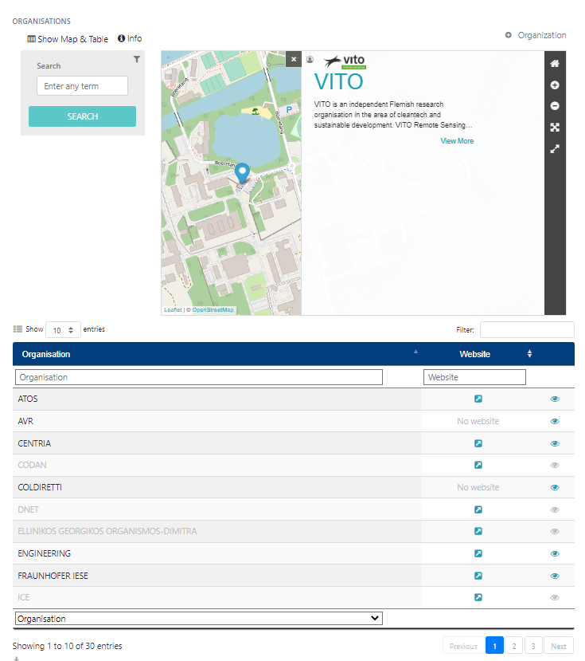

Figure 30 Organisation location marker

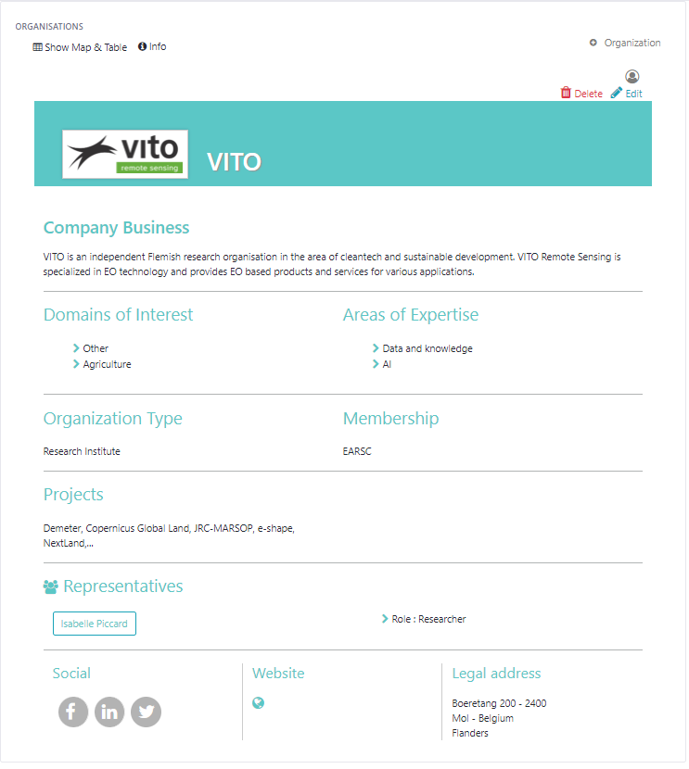

Figure 31 Organisation details

If the user wants to go back to the organisations list, he has to click on the “list” or “Show Map & Table” button (Figure 32).

Figure 32 Go to organisations list

#### Farms

The application allows users to search for farms, see their agri-activities, characteristics, technical infrastructure, etc. The Search functionality allows to search for key words (Figure 33).

If the user has the role of Farm Content Manager, then he will see at the top of the Farm Catalogue, the button “+ Farm”.

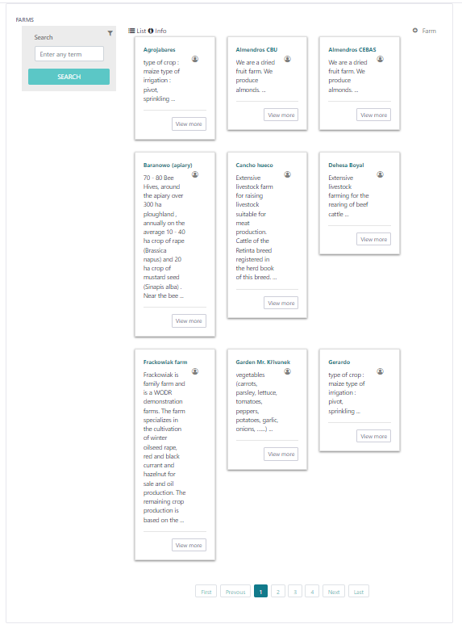

Figure 33 Farms list

For each registered farm, a detailed view is available, clicking on the related card, as shown in Figure 34.

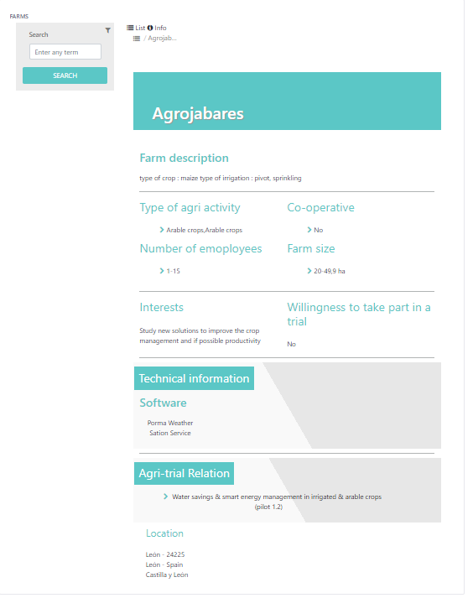

Figure 34 Farm detailed view

If the user wants to go back to the farms list, he has to click on the “list” button.

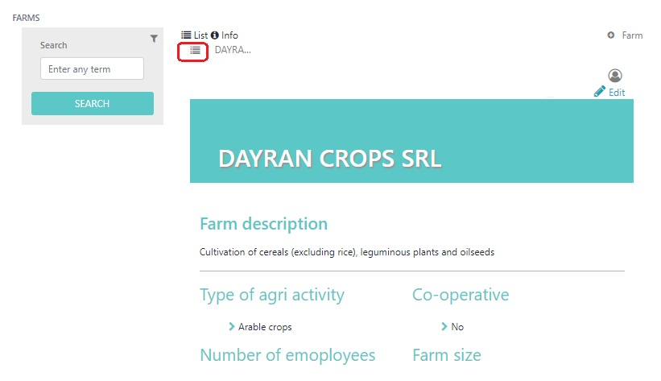

Figure 35 Go to Farms list

#### Pilots

The application includes a collection of agricultural experiments, developed solutions to solve a specific challenge, chosen business models as well implementations characteristics. The Search functionality allows to search for key words (Figure 36).

If the user has the role of Pilot Content Manager, then he will see at the top of the Pilot catalogue, the button “+ Pilot”.

In the description of a pilot, it is possible to add reference to organisations and farms which are pilot’s members; to this end, it’s important that those organisations and farms are already created in the respective catalogues.

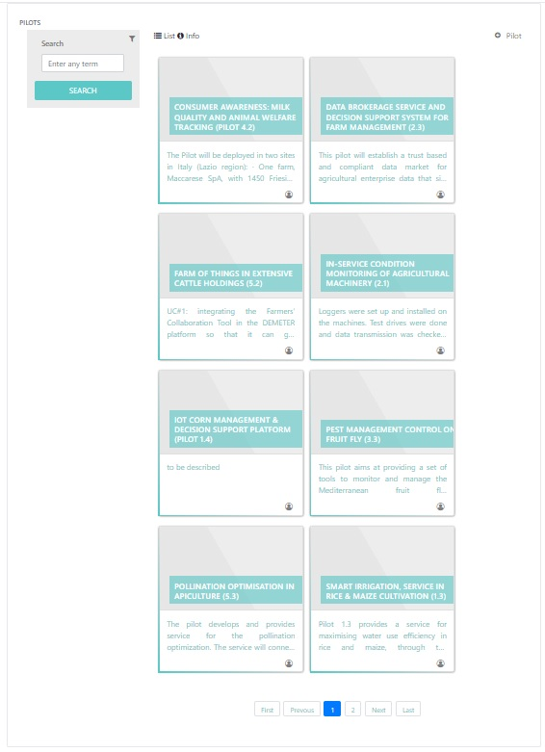

Figure 36 Pilots list

For each registered farm, a detailed view is available, clicking on the related card. If the user wants to go back to the pilot list, he has to click on the “list” button (Figure 37).

Figure 37 Pilot details

### Innovation space

#### Co-creation application

**The Co-Creation Application** aims to enable farmers, software providers and agri-advisory services to work on smart-agri solutions in a collaborative way, thus ensuring the demand-driven development of affordable, accessible and interoperable up-to-date technology that fits farmers' needs.

The co-creation process is still under definition, however it follows these steps:

* A farmer or a farmer association representative or an advisor (with a specific role inside the platform) creates a challenge which consists in a farmer need;
* SOCS users can request to the challenge author to co-create, to design a solution that can answer to that challenge;
* The challenge owner accepts the request and, the user interested in that challenge, can invite other collaborators (i.e. SOCS users with different skills) to co-design the solution. In this way team’s members will work together to design their solution. Different teams can work to design different solutions for the same challenge.
* The team’s members, each one with his own skill, can collaborate to design the solution sharing milestones, documents and answers to the posed questions.
* At the end, the best solution is selected

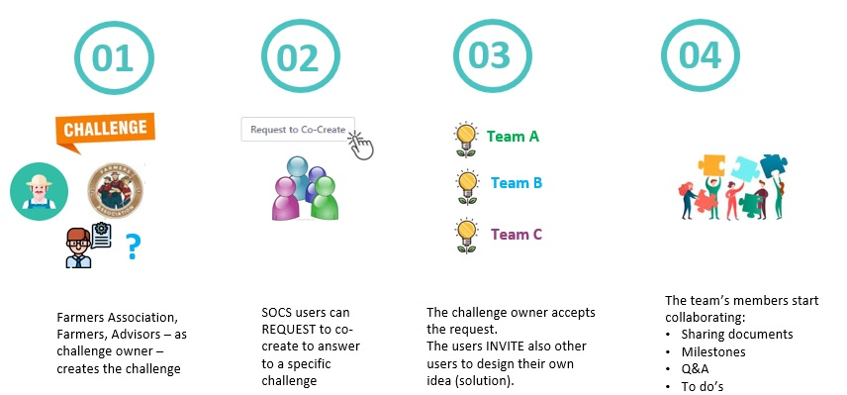

Figure 38 Co-creation process

The co-creation application is visible, in the top bar, as the last application (Figure 39).

Figure 39 Co-creation application

Only users with the “challenge owner” role can create challenges. This role should be given to farmer’s association representatives (who can know farmers’ needs) or farmers who could be supported by advisors in the definition of the challenge. The first interface that the user sees when access the co-creation application, is the list of challenges with a search bar and some filters. Each challenge is represented by a card which includes information such as: title, location, start and end date, status, tags and categories. On the left, the different filters are available, so the user can decide to make a sort by vote and/or by location and/or by category and/or by status, and then clicks the button “Apply filter” (Figure 40).

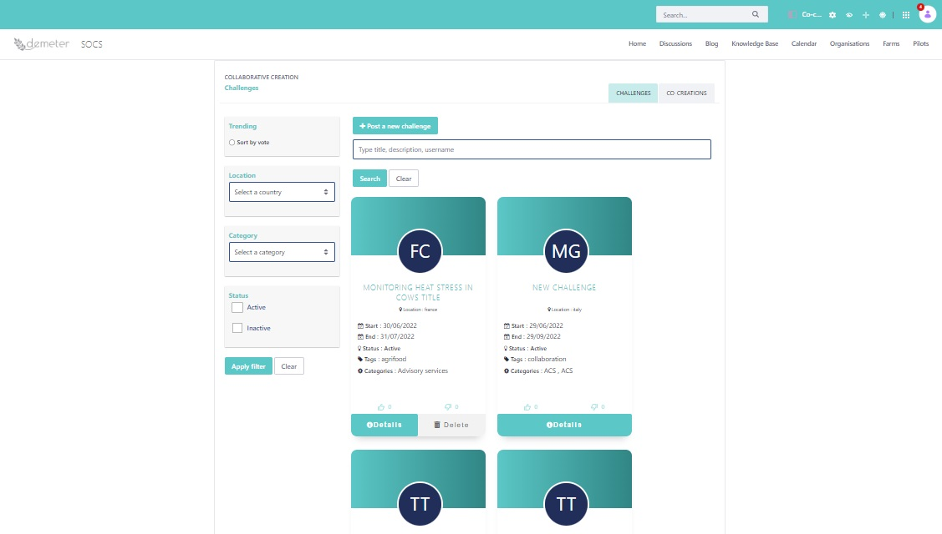

Figure 40 Challenges list

The user with the “challenge owner” role can, through the button “Post a new challenge”, create a new challenge by editing the following attributes: title, description, desired outcome, location, tags, categories, start and end dates, documents and pictures (Figure 41).

Figure 41 New challenge

By clicking on the challenge name or on the details in Figure 40, the user is able to see all the detailed information about the challenge: title, description, desired outcome, location, status, tags and categories, Documents and Pictures and comments already entered. By clicking on the button “Subscribe”, you can be updated if new comments are added (Figure 42).

Figure 42 Challenge details

All the users, who don’t have the “challenge owner” role, can participate to a co-creation, proposing their solution, by entering in the Challenge details and clicking on the button “Request to co-create” (Figure 43).

Figure 43 Request to co-create

The challenge author receives the request via notification (Figure 44) and accepts it.

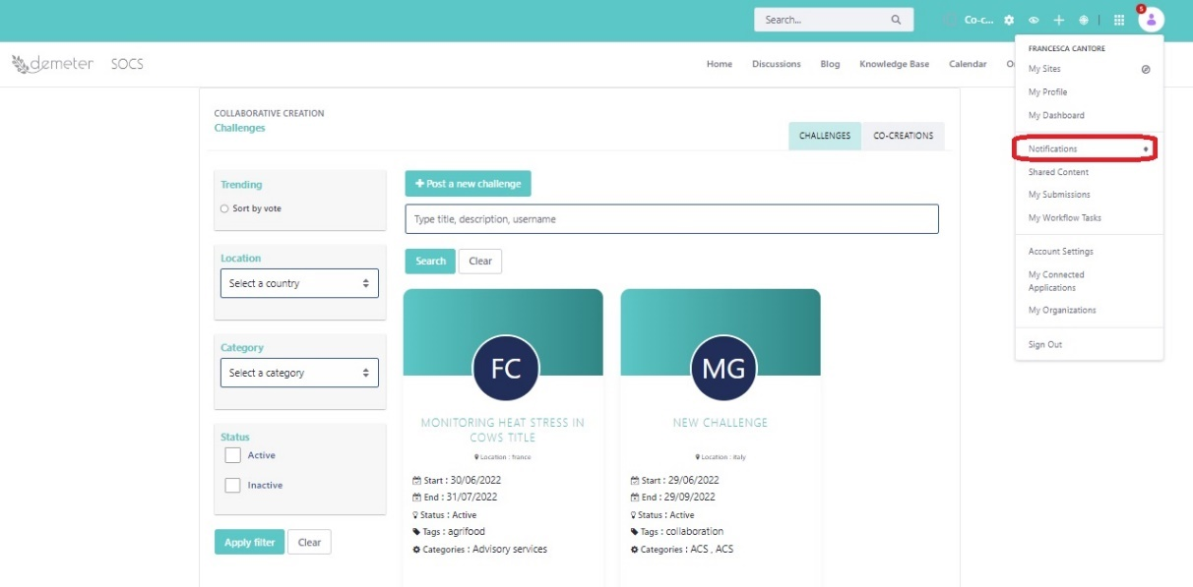

Figure 44 Notification

Once the request is accepted, the user, who has requested to propose a solution, receives a notification as well and can start defining his own co-creation as proposed solution for a specific challenge, reporting the following information: Title, Description, Status, Documents and Pictures. Through this interface, it is also possible to invite other users to take part of the team which will be involved in the co-creation, by using the button “Invite participants” who allows to select specific users. The co-creation interface provides also some functionalities: “Milestones and Deadlines” to be shared with other members of the team invited in the co-creation, “My to do’s” and “Comments”. By clicking on the button “Subscribe”, you can be updated if new comments are added (Figure 45).

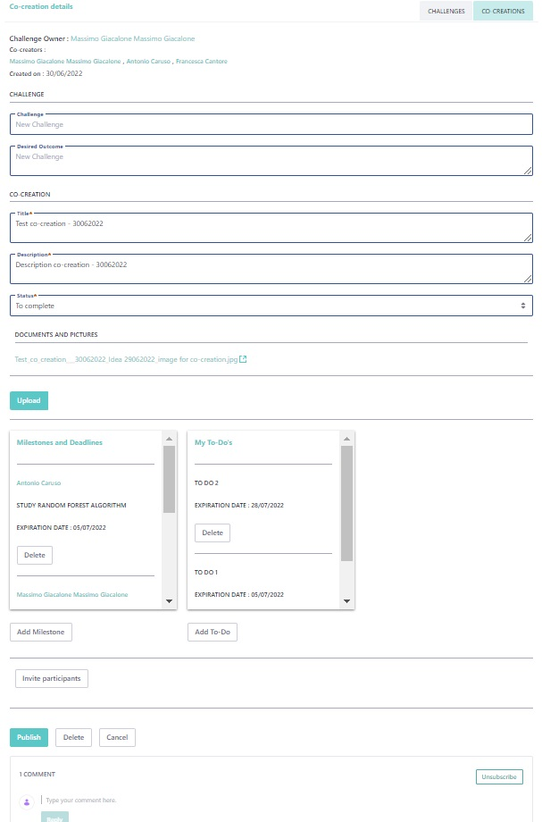

Figure 45 Co-creation

Each user, who has proposed a solution for a specific challenge, can see the co-creation list by clicking on the co-creation tab. Here the co-creations are split in ongoing (if not completed yet) and previous (if completed). In both sections, the user can use the search bar or filter by challenge to find a specific co-creation (Figure 46).

Figure 46 Co-creation list

1. <http://www.liferay.com/> [↑](#footnote-ref-1)